MARYSVILLE JOINT UNIFIED SCHOOL DISTRICT

MARYSVILLE CHARTER

ACADEMY FOR THE ARTS

APPLICATION FOR ENROLLMENT

SCHOOL YEAR 2023-2024

The Marysville Charter Academy for the Arts (MCAA) is a California public charter school for students in grades seven through twelve. Enrollment is open to any resident of Yuba County or counties adjacent to Yuba. Pupils will be considered for admission without regard to race, color, national origin, gender, or disability.

As a charter school, MCAA has a very specific educational mission and purpose. This application is meant to be a tool for helping students and parents/guardians understand MCAA’s instructional and operational philosophies and determining if they are ready to make the commitments required to be successful at the Marysville Charter Academy for the Arts. In the event that the applications for enrollment in any year exceed the school’s capacity, a public, random drawing will be used for admission purposes.

Please read the following description of the Educational Program of the Marysville Charter Academy for the Arts before completing the rest of the application for enrollment.

Return the completed application and all required documents to the Marysville Charter Academy for the Arts, 1917 B Street, Marysville, CA 95901.

Educational Program of the Marysville Charter Academy for the Arts:

The Marysville Charter Academy for the Arts is a college preparatory, secondary level school for students in grades seven through twelve. Its curriculum emphasizes instruction in literary, visual, and performing arts. Students receive instruction in the core subject areas of English, math, science and social science, as well as specialized instruction in a wide variety of the arts. Instruction in the core subject areas is primarily interdisciplinary, thematic, and integrates the arts whenever feasible.

Instruction in all subject areas occurs primarily through project-based learning. Project-based learning is an innovative model for teaching and learning that focuses on the central concepts and principles of a discipline, involves students in problem-solving investigations and other meaningful tasks, allows students to work autonomously and collaboratively to construct their own knowledge, and culminates in realistic products, demonstrations and presentations. Project-based learning is a method well suited for teaching the creative arts, as well as the core curriculum subjects. Assessment of students in all subject areas focuses on the products, portfolios and presentations created by students, while also including traditional evaluation methods where appropriate. Students will be held accountable for the same standards of achievement and course completion as all students in the Marysville Joint Unified School District.

At MCAA students learn to use and apply appropriate technology throughout the academic and creative arts curriculum. They are expected to utilize computer applications effectively throughout their project-based learning program.

High school students are encouraged to identify and develop a specific area of study within the field of creative arts. They create an academic and career plan (Pathway) that includes current and future studies and applications in their area of specialty. Student academic plans include activities that extend learning beyond the walls of the classroom and into the community.

Students at MCAA are expected to develop personal responsibility, skills for productive work in artistic pursuits and careers, and the ability to be a lifelong learner. The vision and focus of MCAA therefore creates an environment for students to become responsible, cooperative and creative learners, who are ready for the future.

STUDENT NAME (as stated on birth certificate)

_____________________________________________________________
Date of Birth
Current Grade in School |  |  | Grade Applying For
Last School Attended
Physical Address Number and Street |  |  |  | City |  | State
Mailing Address Number and Street |  |  |  | City |  | State
Parent/Guardian 1 Name |  |  | Parent/Guardian 1 Home Phone
Parent/Guardian 1 Cell Phone |  |  | Parent/Guardian 1 Work Phone
Parent/Guardian 1 Email
Parent/Guardian 2 Name |  |  | Parent/Guardian 2 Home Phone
Parent/Guardian 2 Cell Phone |  |  | Parent/Guardian 2 Work Phone
Parent/Guardian 2 Email

The Marysville Charter Academy for the Arts solely offers a college preparatory academic program for its students. Students are expected to be responsible, self-disciplined, highly motivated learners. We ask that parents provide the following information to demonstrate their child’s ability or potential to work at grade level. Our purpose is not to be exclusive, but rather ensure that this is the right educational placement for your child. If you do not have copies of any of these documents, they are generally available at your student’s last school of attendance. THESE DOCUMENTS ARE MANDATORY AND MUST BE SUBMITTED TO COMPLETE THE APPLICATION PROCESS:

Copy of current immunization records (including Tdap verification)

Copy of complete report card from the most recent academic year or the most recent high school transcript

Copy of student discipline record or statement from current school’s administrator
- Completed Inter/Intra District Transfer Agreement

Handwritten statement from student, maximum of one page, stating reasons for wanting to attend the Academy, interest and/or experience in the arts, & level of computer proficiency

The following items are optional, but highly recommended to demonstrate potential to be successful, especially if the student has struggled academically in school. THESE DOCUMENTS CAN BE SUBMITTED AFTER THE APPLICATION HAS BEEN ACCEPTED:

Letter of recommendation from teacher or administrator from previous school of attendance, or community member who has worked with the student

Copy of the most current standardized testing report or recent math and reading diagnostic testing results

Copy of qualification documents for special programs, i.e. Gifted and Talented Program (GATE), Resource Program (RSP), American Indian Education, English Language Learner

Parents of all students are highly encouraged to contribute volunteer service to the school each academic year and/or take an active role in supporting the instructional process. Your signature below indicates your understanding of, and agreement to meet, the intent of this commitment.

Parent/Guardian Signature ________________________________
This form (Inter/Intra District Transfer Agreement) must be completed and submitted with the application.

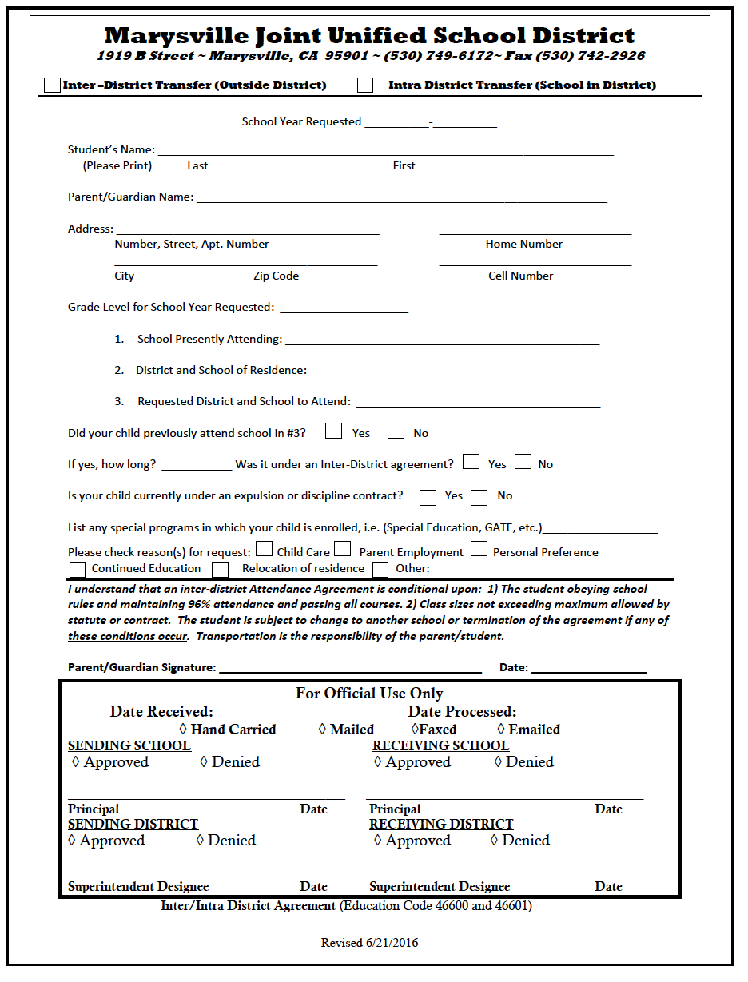

An orientation with both student and parent(s)/guardian(s) is required to complete the application process. Students in the tenth, eleventh and twelfth grade may also be asked to demonstrate their artistic skills, present a portfolio of artwork, or make evident a strong and well-defined interest in the arts. Applicants for the Marysville Charter Academy for the Arts will be contacted to set up a convenient time for the orientation. In addition, an Individual Education Plan (IEP) meeting may be necessary to discuss a change of placement for any special education student.

As part of the orientation process, students and parent(s)/guardian(s) will review the Academy’s student handbook, policies and procedures on attendance, discipline, academic achievement, assessment, transportation, and health and safety to ensure that they understand the policies and expectations of the school.

Thank you for taking the time to complete this application. If you have questions about the application process or the items required, please contact James Lohman, Principal, or Kristen Batchelder, Counselor at 749-6157.

While we understand that this application process can seem intimidating, it is not our intent to exclude any student seriously interested in attending the Marysville Charter Academy for the Arts, regardless of artistic talent or experience. If you and your child understand and agree with the instructional philosophies and educational program of the Academy, we want you to be a part of our community. Again, thank you for taking the time to complete this application.

Return the completed application, Inter/Intra District Transfer Agreement, and all required documents to the Marysville Charter Academy for the Arts, 1917 B Street, Marysville, CA 95901.

Marysville Charter Academy for the Arts
Course Selection 2023-2024

DIRECTIONS: 1) First refer to the Grade Level List and High School Graduation Requirements below to determine your required grade level core classes. Put a check by each required grade level core class in the appropriate department (i.e. English/Language Arts). 2) Next pick a minimum of eight (8) elective classes from the course list, in addition to your checked required courses. Please number the electives in your order of preference, one through eight. Detailed class descriptions are on the school website:www.charter.mjusd.com.

SEVENTH GRADE REQUIRED CLASSES
English 7
Science 7
Social Science 7
Math 7
Physical Education
Study Skills/AVID
Introduction to the Arts

EIGHTH GRADE REQUIRED CLASSES
English 8
Science 8
Social Science 8
Math 8
Physical Education

HIGH SCHOOL GRADUATION REQUIREMENTS (10 credits = 1 year)

Subject Credits required Recommended Grade Level
English 9, 10, 11, 12 40 9th, 10th, 11th, 12th
Biology (Living Earth) 10 9th
Chemistry (Physical Science) 10 10th
Physics (Physical Science) 10 11th
Int. Math 1 or equivalent) 10 8th or 9th
Math (Int. Math 2 or equivalent) 10 9th or 10th
Math (Int. Math 3 or equivalent) 10 10th or 11th
World History 10 10th
United States History 10 11th
Civics 5 12th
Economics 5 12th
Health 5 9th
Careers 5 9th
Physical Education 20 9th and 10th
Visual & Performing Arts/ 20 9th through 12th
Foreign Language/Career Technical
Education
Electives 40 9th through 12th
220 Total Required

Classes must be taken in sequence. Advanced classes and some intermediate classes require teacher recommendation.

ENGLISH/LANGUAGE ARTS
_____ English 7
_____ English 8
_____ English 9-P _____ Honors English 9-P
_____ English 10-P _____ Honors English 10-P
_____ English 11-P _____ Honors English 11-P
_____ English 12-P
_____ Advanced Placement English Literature and Composition
_____ Advanced Placement English Language and Composition

SCIENCE
_____ Science 7
_____ Science 8
_____ Biology/Living Earth-P (9th Grade)
_____ Chemistry/ChemEarSpace-P (10th Grade, Completion of Biology/Living Earth required)
_____ Physics/PhyEarSpace-P (11th Grade, Completion of Int. Math 2 required)
_____ Advanced Placement Environmental Science-P

MATHEMATICS
_____ Math 7
_____ Math 8
_____ Integrated Math 1-P
_____ Integrated Math 2-P
_____ Integrated Math 3-P
_____ Advanced Integrated Math 3/Pre-Calculus-P
_____ Advanced Placement Pre-Calculus-P
_____ Advanced Placement Calculus-P
_____ Math Support (By Grade Level)

SOCIAL SCIENCE
_____ History 7
_____ History 8
_____ World History-P (10th Grade)
_____ United States History-P (11th Grade)
_____ Civics-P (12th Grade, Fall) _____ Economics-P (12th Grade, Spring)

STATE REQUIREMENTS (9th Grade)
_____ Health
_____ Careers

Classes must be taken in sequence. Advanced classes and some intermediate classes require teacher recommendation.

CAREER TECHNICAL EDUCATION
_____ Graphic Arts 1
_____ Graphic Design-P
_____ Technical Theater 1-P
_____ Technical Theater 2-P
_____ Intermediate Dance B-P (High School P.E. credits completion required)
_____ Advanced Dance-P (High School P.E. credits completion required)
_____ Intermediate Drama-P ( high school only)
_____ Advanced Drama-P ( high school only)
_____ Advanced Piano-P
_____ Advanced Placement Music Theory-P (Teacher Recommendation Required)

PHYSICAL EDUCATION
_____ Dance Basics
_____ Dance 1.5
_____ Dance 2
_____ Dance 3
_____ Kuk Sool Won 1 (Self-defense, Martial Arts)
_____ Kuk Sool Won 2
_____ Kuk Sool Won 3
_____ Yoga/Pilates

FINE ARTS/DANCE
_____ Intermediate Dance A-P (High School P.E. credits completion required)
_____ Intermediate Dance B-P (High School P.E. credits completion required)
_____ Advanced Dance-P (High School P.E. credits completion required)

FINE ARTS/DRAMA
_____ Beginning Drama-P (Beginning 7/8/9)
_____ Intermediate Drama-P (high school only)
_____ Advanced Drama-P (high school only)

FINE ARTS/VISUAL ARTS
_____ Art 1-P
_____ Art 2-P
_____ Art 3-P
_____ AP Studio Art-P (Drawing/Painting, 2D, 3D)
_____ Photography 1-P
_____ Advanced Photography-P

Classes must be taken in sequence. Advanced classes and some intermediate classes require teacher recommendation.

FINE ARTS/MUSIC
_____ Beginning Choir
_____ Concert Choir-P (Intermediate/Advanced)
_____ Beginning Piano-P
_____ Advanced Piano-P
_____ Drum Line
_____ Beginning Band
_____ Advanced Concert Band-P
_____ Advanced Jazz Band-P
_____ Beginning Guitar 1-P
_____ Advanced Guitar 2
_____ Beginning Strings (Violin, Cello, Bass)
_____ Intermediate Strings
_____ Advanced Strings-P
_____ Songwriting/Music Theory
_____ Advanced Placement Music Theory-P (Teacher Recommendation Required)

WORLD LANGUAGES
____ French 1 (Yuba College Class)
_____ French 2 (Yuba College Class)
_____ Spanish 1-P
_____ Spanish 2-P
_____ Spanish 3/4-P
_____ Advanced Placement Spanish Language-P
_____ American Sign Language 1 (Yuba College Concurrent Class)
_____ American Sign Language 2 (Yuba College Concurrent Class)

ELECTIVES
_____ Beginning Creative Writing
_____ Advanced Creative Writing-P
_____ Yearbook (9-12 Grade only)
_____ Study Hall (8th-12th Grade)
_____ Teacher Assistant (Grades 10-12, Teacher recommendation required)
_____ Math Support (By Grade Level)

MARYSVILLE CHARTER ACADEMY FOR THE ARTS

DAILY SCHEDULE

2023-2024
(Subject to change)

BLOCK 1 OR 2 7:50 9:15

BREAK 9:15 9:25

PASSING 9:25 9:30

BLOCK 3 OR 4 9:30 10:55

PASSING 10:55 11:00

BLOCK 9 11:00 11:30

LUNCH 11:30 12:10

BLOCK 5 OR 6 12:10 1:30

PASSING 1:30 1:35

BLOCK 7 OR 8 1:35 2:58

